**A SEMINAR REPORT**

**ON**

**BLUE EYE TECHNOLOGY**

SUBMITTED TO THE SAVITRIBAI PHULE PUNE UNIVERSITY,

IN PARTIAL FULLFILMENT OF THE REQUIREMENTS

FOR THE AWARD OF THE DEGREE

OF

THIRD YEAR COMPUTER ENGINEERING

BY

KADAKE SHIVANI ROLL N0:20U410

UNDER THE GUIDANCE OF

Prof. P. A. Deole



DEPARTMENT OF COMPUTER ENGINEERING

STES’S SMT KASHIBAI NAVALE COLLEGE OF ENGINEERING VADGAON BK, OFF SINHAGAD ROAD

PUNE – 411041

March 2015



**CERTIFICATE**

This is to certify that the seminar report entitled

**BLUE EYE TECHNOLOGY**

submitted by

**KADAKE SHIVANI ROLL NO:-20U410**

is a bonafide work carried out by her under the supervision of **Prof. P. A. Deole** and it is approved for the partial fulfillment of the requirement of Savitribai Phule Pune University, Pune for the award of the degree of Bachelor of Engineering(Computer Engineering)

Prof. P. A. Deole V. V. Kimbahune

Seminar Guide Head of Department

Department of Computer Engineering Department of Computer Engineering

Place: Dr. A. V. Deshpande

Date: Principal

**ACKNOWLEDGMENT**

With due respect and gratitude I take the opportunity to thank those who have helped me directly and indirectly. I convey my sincere thanks **to Prof. V. V. Kimbahune** , HoD Computer Dept. and **Prof P. A. Deole** for their help in selecting the seminar topic and support.

I thank to my seminar guide **Prof P. A. Deole** for his guidance, timely help and valuable suggestions without which this seminar would not have been possible. His direction has always been encouraging as well as inspiring for me. Attempts have been made to minimize the errors in the report.

I would also like to express my appreciation and thanks to all my friends who knowingly or unknowingly have assisted and encourage me throughout my hard work.

Finally how can I forget the almighty the supreme power the GOD and my loving parents without which this work task was a distant dream. . . . . . .

**Ms.Kadake Shivani** (ROLL NO : 20U410)

T.E. Computer(III year) 2019

**ABSTRACT**

Is it possible to create a computer, which can interact with us as we interact with each other? For example imagine in a fine morning you walk on to your computer room and switch on your computer, and then it tells you “hey friend, good morning you seem to be a bad mood today. And then it opens your mail box and shows you some of the mails and tries to cheer you. It seems to be a fiction, but it will be the life lead by “blue eyes” in the very near future. The basic idea behind this technology is to give the computer the human power. We all have some perceptual abilities. That is we can understand each other’s feelings. For example we can understand one’s emotional state by analyzing his facial expression. If we add these perceptual abilities of human to computers would enable computers to work together with human beings as intimate partners. The “blue eyes” technology aims at creating computational machines that have perceptual and sensory ability like those of human beings. This paper discusses the concept of blue eyes technology. Keywords: blue eyes, emotional mouse, expression glass, led, visualization.

**CONTENTS**

CERTIFICATE …………………………………………………2

ACKNOWLEDGMENT …………………………………3

ABSTRACT……………………………………………4

1. INTRODUCTION ……………………………………….7
2. LITERATURE SURVEY………………………………..9
3. EXISTING SYSTEM …………………………………..10
   1. DATA ACQUISITION UNIT……………………………11

3.3 CENTRAL SYSTEM UNIT …………………………….12

3.4 TYPES OF EMOTION SENSORS………………………13

3.4.1 HAND …………………………………………….13

3.4.1.1 EMOTION MOUSE………………………13

3.4.1.2 SENTIC MOUSE………………………….13

3.4.2 EYE ……………………………………………….14

3.4.2.1 EXPRESSION GLASSES………………………14

3.4.3 MANUAL & GAZE INPUT CASCADED(MAGIC)………….15

3.4.4 SIMPLE USER INTEREST TACKER(SUITOR)……………..16

3.4.5 ARTIFICIAL INTELLIGENCE SPEECH RECOGNIZATION………………………………….17

4. PROPOSED SYSTEM ……………………………………………18

4.1 IBM BLUE EYES……………………………………………..18

4.2 MULTI CAMERA IR BASED EYE TRACKING……………..18

4.3 THE SOFTWARE………………………………………………19

4.3.1 CONNECTION MANAGER……………………………..19

4.3.2 DATA ANALYSIS MODULE……………………………20

4.3.3 VISUALIZATION MODULE…………………………….20

5. ADVANTAGES AND DISADVANTAGES ADVANTAGES……………………………………………………..21

6. APPLICATIONS …………………………………………….23

7. CONCLUSION……………………………………………..24

8. FUTURE WORKS ……………………………………….25

9. REFERENCES …………………………………………….26

**Chapter 1**

**INTRODUCTION**

Imagine yourself in a world where humans interact with computers. You are sitting in front of your personal computer that can listen, talk, or even scream aloud. It has the ability to gather information about you and interact with you through special techniques like facial recognition, speech recognition, etc. It can even understand your emotions at the touch of the mouse. It verifies your identity, feels your presents, and starts interacting with you .You asks the computer to dial to your friend at his office. It realizes the urgency of the situation through the mouse, dials your friend at his office, and establishes a connection. Human cognition depends primarily on the ability to perceive, interpret, and integrate audio-visuals and censoring information. Adding extraordinary perceptual abilities to computers would enable computers to work together with human beings as intimate partners. Researchers are attempting to add more capabilities to computers that will allow them to interact like humans, recognize human presents, talk, listen, or even guess their feelings.

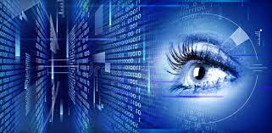

The BLUE EYES technology aims at creating computational machines that haven Perceptual and sensory ability like those of human beings. It uses non-obtrusive sensing method, employing most modern video cameras and microphones to identify the user’s actions through the use of imparted sensory abilities. The machine can understand what a user wants, where he is looking at, and even realize his physical or emotional states. BLUE EYE TECHNIQUE JIEMS AKKALKUWA 2 Human cognition depends primarily on the ability to perceive, interpret, and integrate audio-visuals and censoring information. Adding extraordinary perceptual abilities to computers would enable computers to work together with human beings as intimate partners. Researchers are attempting to add more capabilities to computers that will allow them to interact like humans, recognize human presents, talk, listen, or even guess their feelings.

**Chapter 2**

**LITERATURE SURVEY**

Rosalind Picard (1997) describes why emotions are important to the computing community. There are two aspects of affective computing: giving the computer the ability to detect emotions and giving the computer the ability to express emotions. Not only are emotions crucial for rational decision making as Picard describes, but emotion detection is an important step to an adaptive computer system. An adaptive, smart computer system has been driving our efforts to detect a person’s emotional state. By matching a person’s emotional state and the context of the expressed emotion, over a period of time the person’s personality is being exhibited. Therefore, by giving the computer a longitudinal understanding of the emotional state of its user, the computer could adapt a working style which fits with its user’s personality.

The result of this collaboration could increase productivity for the user. One way of gaining information from a user non-intrusively is by video. Cameras have been used to detect a person’s emotional state (Johnson, 1999). We have explored gaining information through touch. One obvious place to put sensors is on the mouse. Through observing normal computer usage (creating and editing documents and surfing the web), people spend approximately 1/3 of their total computer time touching their input device. Because of the incredible amount of time spent touching an input device, we will explore the possibility of detecting emotion through touch.

Human cognition depends primarily on the ability to perceive, interpret, and integrate audio-visuals and censoring information. Adding extraordinary perceptual abilities to computers would enable computers to work together with human beings as intimate partners. Researchers are attempting to add more capabilities to computers that will allow them to interact like humans, recognize human presents, talk, listen, or even guess their feelings.

**Chapter 3**

**EXISTING SYSTEM**

System provides technical means for monitoring and recording the operator’s basic physiological parameters. The most important parameter is saccadic activity1, which enables the system to monitor the status of the operator’s visual attention along with head acceleration, which accompanies large displacement of the visual axis (saccades larger than 15 degrees). Complex industrial environment can create a danger of exposing the operator to toxic substances, which can affect his cardiac, circulatory and pulmonary systems. Thus, on the grounds of lathy some graphic signal taken from the forehead skin surface, the system computes heart beat rate and blood oxygenation. The BLUE EYES system checks above parameters against abnormal (e.g. a low level of blood oxygenation or a high pulse rate) or undesirable (e.g. a longer period of lowered visual attention) values and triggers user-defined alarms when necessary.

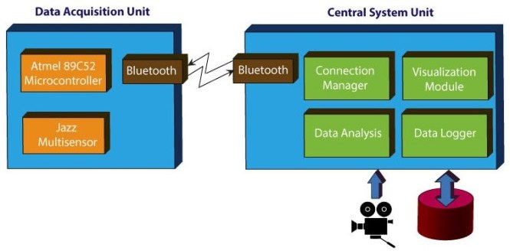

Quite often in an emergency situation operators speak to themselves expressing their surprise or stating verbally the problem. Therefore, the operator’s voice, physiological parameters and an overall view of the operating room are recorded. This helps to reconstruct the course of operators’ work and provides data for long-term analysis. This system consists of a mobile measuring device and a central analytical system. The mobile device is integrated with Bluetooth module providing wireless interface between sensors worn by the operator and the central unit. ID cards assigned to each of the operators and adequate user profiles on the central unit side provide necessary data personalization so different people can use a single mobile device.

**3.2 DATA ACQUISITION UNIT**

Data Acquisition Unit is a mobile part of the Blue eyes system. Its main task is to fetch the physiological data from the sensor and to send it to the central system to be processed. To accomplish the task the device must manage wireless Bluetooth connections (connection establishment, authentication and termination). Personal ID cards and PIN codes provide operator's authorization. Communication with the operator is carried on using a simple 5-key keyboard, a small LCD display and a beeper. When an exceptional situation is detected the device uses them to notify the operator. Voice data is transferred using a small headset, interfaced to the DAU with standard mini-jack plugs. The Data Acquisition Unit comprises several hardware modules • Atmel 89C52 microcontroller - system core • Bluetooth module (based on ROK101008) • HD44780 - small LCD display • 24C16 - I2C EEPROM (on a removable ID card) • MC145483 – 13bit PCM codec • Jazz Multi sensor interface • Beeper and LED indicators ,6 AA batteries and voltage level monitor.

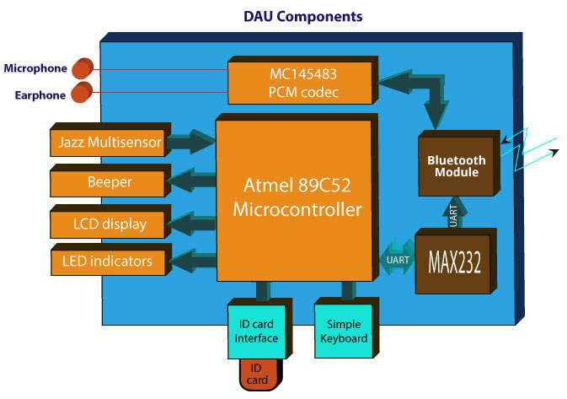

**3.3 CENTRAL SYSTEM UNIT**

Central System Unit hardware is the second peer of the wireless connection. The box contains a Bluetooth module (based on ROK101008) and a PCM codec for voice data transmission. The module is interfaced to a PC using a parallel, serial and USB cable. The audio data is accessible through standard mini-jack sockets to program operator's personal ID cards we developed a simple programming device. The programmer is interfaced to a PC using serial and PS/2 (power source) ports. Inside, there is Atmel 89C2051 microcontroller, which handles UART transmission and I2C EEPROM (ID card) programming.

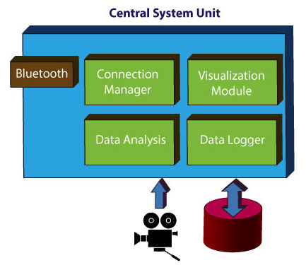

**3.4 TYPES OF EMOTION SENSORS**

**3.4.1 HAND**

**3.4.1.1 EMOTION MOUSE**

The mouse includes a set of sensors, including infrared detectors and temperaturesensitive chips. These components, User researchers’ stress, will also be crafted into other commonly used items such as the office chair, the steering wheel, the keyboard and the phone handle. Integrating the system into the steering wheel, for instance, could allow an alert to be sounded when a driver becomes drowsy.

**3.4.1.2 SENTIC MOUSE**

It is a modified computer mouse that includes a directional pressure sensor for aiding in recognition of emotional valence (liking/attraction vs. disliking/avoidance)

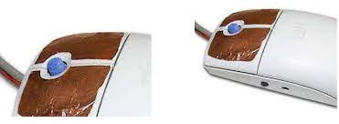

**3.4.2 EYE**

**3.4.2.1 EXPRESSION GLASSES**

A wearable device which allows any viewer to visualize the confusion and interest levels of the wearer. Other recent developments in related technology are the attempt to learn the needs of the user just by following the interaction between the user and the computer in order to know what he/she is interested in at any given moment. For example, by remembering the type of websites that the user links to according to the mood and time of the day, the computer could search on related sites and suggest the results the user.

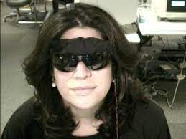

**3.4.3 MANUAL & GAZE INPUT CASCADED(MAGIC)**

This work explores a new direction in utilizing eye gaze for computer input. Gaze tracking has long been considered as an alternative or potentially superior pointing method for computer input. We believe that many fundamental limitations exist with traditional gaze pointing. In particular, it is unnatural to overload a perceptual channel such as vision with a motor control task. We therefore propose an alternative approach, dubbed MAGIC (Manual and Gaze Input Cascaded) pointing. With such an approach, pointing appears to the user to be a manual task, used for fine manipulation and selection. However, a large portion of the cursor movement is eliminated by warping the cursor to the eye gaze area, which encompasses the target. Two specific MAGIC pointing techniques, one conservative and one liberal, were designed, analyzed, and implemented with an eye tracker we developed. They were then tested in a pilot study.

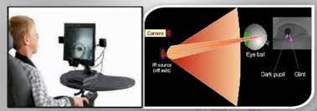

**3.4.4 SIMPLE USER INTEREST TACKER(SUITOR)**

SUITOR continuously analyses the user that where his/her eyes focuses on his/her personal computer screen. And with such ability it determines the topic of interest of user and according to that it can deliver the appropriate data. Attentive systems pay attention to what users do so that they can attend to what users need. SUITOR based systems pay attention to what users do so that they can give information regarding users need. Suitor systems track user behavior, model user interests, and collect user desires and actions. Because the general class of attentive systems is broad — ranging from human butlers to web sites that profile users — we have focused specifically on attentive information systems, which observe user actions with information resources, model user information states, and suggest information that might be helpful to users. In particular, we describe an implemented system, Simple User Interest Tracker (Suitor), that tracks computer users through multiple channels — gaze, web browsing, application focus — to determine their interests and to satisfy their information needs. By observing behaviour and modelling users, Suitor finds and displays potentially relevant information that is both timely and non-disruptive to the users’ ongoing activities.



**3.4.5 ARTIFICIAL INTELLIGENCE SPEECH RECOGNIZATION**

To implement Artificial Intelligent voice recognition, it is very necessary to consider the working environment. The grammar used by the speaker and accepted by the system, noise level, noise type, position of the microphone, and speed and manner of the user’s speech are some factors that may affect the quality of speech recognition. This system is for automatic callhandling without any telephone operator. It is important to consider the environment in which the speech recognition system has to work. The grammar used by the speaker and accepted by the system, noise level, noise type, position of the microphone, and speed and manner of the user’s speech are some factors that may affect the quality of speech recognition. The user Speaks to the computer through a microphone, which, in used; a simple system may contain a minimum of three filters. The more the number of filters used, the higher the probability of accurate recognition. Presently, switched capacitor digital filters are used because these can be custombuilt in integrated circuit form. These are smaller and cheaper than active filters using operational amplifiers. The filter output is then fed to the ADC to translate the analogue signal into digital word. The ADC samples the filter outputs many times a second. Each sample represents different amplitude of the signal. Each value is then converted to a binary number Proportional to the amplitude of the sample. A central processor unit (CPU) controls the input circuits that are by the ADCS. A large RAM (random access memory) stores all the digital values in a buffer area. This digital information, representing the spoken word, is now accessed by the CPU to process it further. The normal speech has a frequency range of 200 Hz to 7 kHz. Recognizing a telephone call is more difficult as it has bandwidth limitation of 300 Hz to3.3 kHz**.**



**Chapter 4**

**PROPOSED SYSTEM**

**4.1 IBM BLUE EYES**

The system uses IBM Blue Eyes infrared lighting cameras. These cameras are used as sensors for our eye tracking algorithm and the tracked eyes are used in conjunction to estimate the user's head pose and eye gaze direction. Each eye tracker utilizes a simple dynamics model of eye movements along with Kalman filters and appearance models to track the eyes robustly in real-time and under widely varying lighting conditions. The tracked head pose is used to estimate a user's eye gaze to measure whether a user is looking at a previously defined region of interest that the prototype applications use to further interact with the user.

**4.2 MULTI CAMERA IR BASED EYE TRACKING**

Multi camera IR based eye tracking several pre-calibrated cameras to estimate a user's head pose are used. For each camera, we use the tracked eye locations to estimate mouth corners. These two mouth corners and eye positions are then used as low level features between all cameras to estimate the user's 3D head pose. A combination of stereo triangulation, noise reduction via interpolation is used, and a camera switching metric to use the best subsets of cameras for better tracking as a user is moving their head in the tracking volume. Multiple cameras provide both a large tracking volume as well as 3D head pose information. However, as a user moves in the tracking volume, it is possible that their eyes are no longer visible from some cameras.

**4.3 THE SOFTWARE**

Blue Eyes software’s main task is to look after working operators' physiological condition. To assure instant reaction on the operators' condition change the software performs real time buffering of the incoming data, real-time physiological data analysis and alarm triggering.

**4.3.1 CONNECTION MANAGER**

is responsible for managing the wireless communication between the mobile Data Acquisition Units and the central system. The Connection Manager handles:

• Communication with the CSU hardware

• Searching for new devices in the covered range

• Establishing Bluetooth connections

• Connection authentication

• Incoming data buffering & sending alert

**4.3.2 DATA ANALYSIS MODULE**

performs the analysis of the raw sensor data in order to obtain information about the operator’s physiological condition. The separately running Data Analysis module supervises each of the working operators. The module consists of a number of smaller analyzers extracting different types of information. Each of the analyzers registers at the appropriate Operator Manager or another analyzer as a data consumer and, acting as a producer, provides the results of the analysis. The most important analyzers are:

• Saccade detector - monitors eye movements in order to determine the level of operator's visual attention

• Pulse rate analyzer - uses blood oxygenation signal to compute operator's pulse rate

• Custom analyzers - recognize other behaviors than those which are built-in the system. The new modules are created using C4.5 decision tree induction algorithm

**4.3.3 VISUALIZATION MODULE**

provides a user interface for the supervisors. It enables them to watch each of the working operator’s physiological condition along with a preview of selected video source and related sound stream. All the incoming alarm messages are instantly signaled to the supervisor. The Visualization module can be set in an offline mode, where all the data is fetched from the database. Watching all the recorded physiological parameters, alarms, video and audio data the supervisor is able to reconstruct the course of the selected operator’s duty. The physiological data is presented using a set of custom-built GUI controls:

• Pie-chart used to present a percentage of time the operator was actively acquiring the visual information

• A VU-meter showing the present value of a parameter time series displaying a history of selected parameters' value

**Chapter 5**

**ADVANTAGES AND DISADVANTAGES**

**ADVANTAGES**

• Prevention from dangerous incidents.

• Physiological condition monitoring.

• Operators position detection.

• The reconstruction of the course of operator’s work.

• It can help different forms of information systems.

• A more natural mental model for user.

• Faster than pure manual pointing.

• Practical accuracy level

**DISADVANTAGES**

• One disadvantage is its reliability.

• The cursor warping can be overactive at times.

• The motor action computation (decision) cannot start until the cursor appears.

• Liberal approach is distracting when the user is trying to read.

• The system is too costly.

• The system needs complex arrangements.

**Chapter 6**

**APPLICATIONS**

• Blue Eyes is developing ways for computers to anticipate users' wants by gathering video data on eye movement and facial expression. Your gaze might rest on a Web site heading, for example, and that would prompt your computer to find similar links and to call them up in a new window. But the first practical use for the research turns out to be snooping on shoppers.

• Blue Eyes software makes sense of what the cameras see to answer key questions for retailers, including, how many shoppers ignored a promotion? How many stopped? How long did they stay? Did their faces register boredom or delight? How many reached for the item and put it in their shopping carts? Blue Eyes works by tracking pupil, eyebrow and mouth movement. When monitoring pupils, the system uses a camera and two infrared light sources placed inside the product display. One light source is aligned with the camera's focus; the other is slightly off axis.

• When the eye looks into the camera-aligned light, the pupil appears bright to the sensor, and the software registers the customer's attention. This is way it captures the person's income and buying preferences. Blue Eyes is actively been incorporated in some of the leading retail outlets.

• Another application would be in the automobile industry. By simply touching a computer input device such as a mouse, the computer system is designed to be able to determine a person's emotional state for cars, it could be useful to help with critical decisions like: "I know you want to get into the fast lane, but I'm afraid I can't do that. Your too upset right now" and therefore assist in driving safely.

• Current interfaces between computers and humans can present information vividly, but have no sense of whether that information is ever viewed or understood. In contrast, new real-time computer vision techniques for perceiving people allows us to create "Face-responsive Displays" and "Perceptive Environments", which can sense and respond to users that are viewing them. Using stereo-vision techniques, we areable to detect, track, and identify users robustly and in real time. This information can make spoken language interface more robust, by selecting the acoustic information from a visually-localized source. Environments can become aware of how many people are present, what activity is occurring, and therefore what display or messaging modalities are most appropriate to use in the current situation.

• The results of our research will allow the interface between computers and human users to become more natural and intuitive .We could see its use in video games where, it could give individual challenges to customers playing video games. Typically targeting commercial business. The integration of children's toys, technologies and computers is enabling new play experiences that were not commercially feasible until recently. The Intel Play QX3 Computer Microscope, the Me2Cam with Fun Fair, and the Computer Sound Morphed are commercially available smart toy products developed by the Intel Smart Toy Lab in. One theme that is common across these PC-connected toys is that users interact with them using a combination of visual, audible and tactile input & output modalities. The presentation will provide an overview of the interaction design of these products and pose some unique challenges faced by designers and engineers of such experiences targeted at novice computer users, namely young children.

• The familiar and useful come from things we recognize. Many of our favorite things' appearance communicate their use; they show the change in their value though patina. As technologists we are now poised to imagine a world where computing objects communicate with us in-situ; where we are. We use our looks, feelings, and actions to give the computer the experience it needs to work with us. Keyboards and mice will not continue to dominate computer user interfaces. Keyboard input will be replaced in large measure by systems that know what we want and require less explicit communication. Sensors are gaining fidelity and ubiquity to record presence and actions; sensors will notice when we enter a space, sit down, lie down, pump iron, etc.

**Chapter 7**

**CONCLUSION**

The BLUE EYES technology ensures a convenient way of simplifying the life by providing more delicate and user friendly facilities in computing devices. Now that we have proven the method, the next step is to improve the hardware. Instead of using cumbersome modules to gather information about the user, it will be better to use smaller and less intrusive units. The ability of our system to track user head pose over multiple cameras in indoor settings is demonstrated. Several users may be able to perform the tracking under varying lighting conditions very robustly. In addition, present a framework is presented to seamlessly integrate vision-based system with application prototypes to make higher-level inferences about user behavior. The nineties witnessed quantum leaps interface designing for improved man machine interactions.

**Chapter 8**

**FUTURE WORKS**

The feedback from the user studies could be used to modify the granularity of head pose data provided by the tracking system. A proper planning can be thought of to investigate how effective the gaze data has been in facilitating family communications and what new social implications arise from these kinds of perceptual systems. Several more experiments can be conducted with several other application prototypes to explore new avenues for using perceptual interfaces based on vision-based system. IBM, Sony and MIT (Massachusetts Institute of Technology) are the important pioneers in the field. Success achieved in implementation of the technology has been limited as they have a lot of challenges to encounter on their path. Identifying different emotional states by translating the neurological activities has been a major challenge.

Research is still going on in the field and commercial availability of the technology is expected to be in sometime very soon. The technology on its successful implementation has got limitless application in every possible industry out there in the world. Interactive environment will be built where anything is possible without making the user feel that the technology is actually complex in nature. Till today the technology advancement has required the users to adapt themselves to the technology by dedicating time to learning what it is all about, making them feel they are ignorant of it. This new technology actually will make the user more comfortable. Many Business aspects are also involved in the future. From marketing perspective of business, the targeted customers can be attracted with interactive entertainment and advertisement. Live feedbacks of the customers can be observed and recorded without much bothering the customers with the old method of person to person feedback collection mechanism with questionnaire.

The reaction to the advertisements can be taken as a part of the feedback from the customers. The information about their major competitors and how the consumers feel about them can be obtained.

**Chapter 9**

**REFERENCES**

• <http://www.wikipedia.com>

• <http://www.techreview.com>

• <http://www.almaden.ibm.com>

• <http://www.research.ibm.com>

• <http://www.metropolismag.com>

• <http://www.visuallee.com>

• <http://www.howstuffworks.com>